***Curriculum vitae***

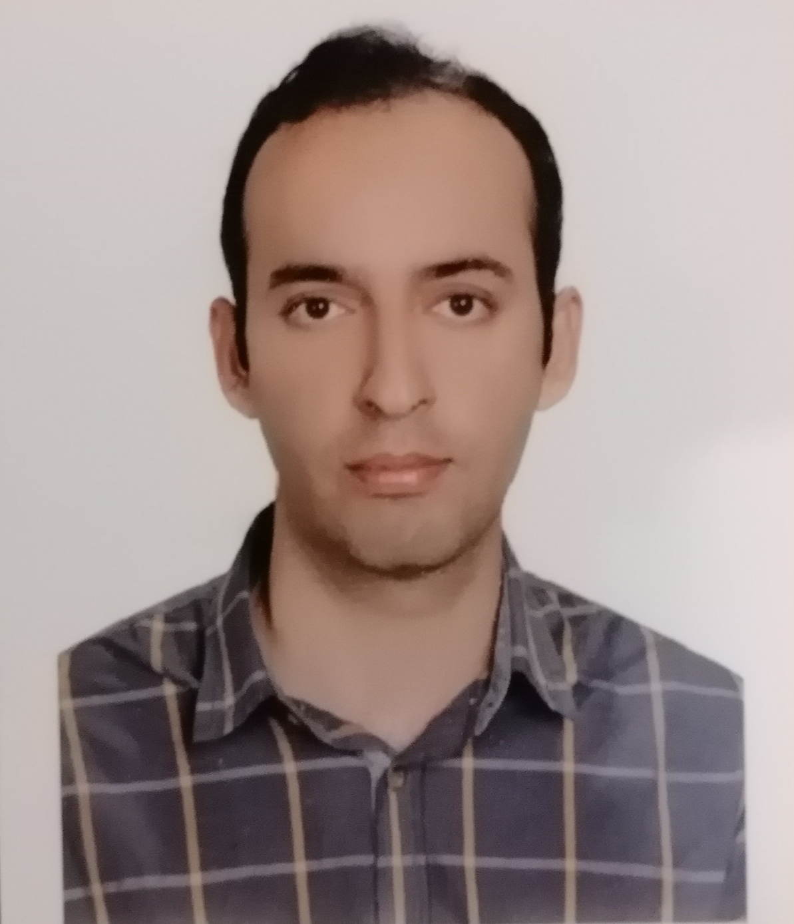

**Personal Information**  
**Name**: Seyed Hossein Sadeghi  
**Date of birth:** 1988   August  21  
**Place of Birth:** Sari, Iran  
**Contact Address:** Genomic Research Center, Shahid Beheshti University of Medical Sciences, Tehran, Iran  
**Cell phone:** +98-919-0334976  
**E-mail:** [hsadeqi86@gmail.com](mailto:hsadeqi86@gmail.com), Hosseinsadeghi@sbmu.ac.ir  
**Education**  
**Ph.D:** Department of Medical Genetics, Shahid Beheshti University of Medical Sciences, 2019, Tehran, Iran  
**M.Sc:** Department of Medical Genetics, Golestan University of Medical Sciences, 2015, Gorgan, Iran  
**B. Sc**: Biology, Faculty of Basic Sciences, Kharazmi University, 2012, Tehran, Iran

**M.Sc thesis**

Study the effect of *CDC25A* gene silencing on proliferation of breast cancer cell line MDA-MB-231

**Ph.D thesis**

Investigation of genetic and epigenetic factors affecting the vitamin D metabolism pathway with focused on the *CYP24A1* gene in colorectal cancer tissue

**Publications**

1. Sadeghi H, Hashemnia V, Nazemalhosseini-Mojarad E, Ghasemi MR, Mirfakhraie R. Correlated downregulation of VDR and CYP3A4 in colorectal cancer. Molecular Biology Reports. 2022 Dec 5:1-7.
2. Yassaee VR, Khojasteh A, Hashemi‐Gorji F, Sadeghi H, Safiaghdam H, Mirfakhraie R. Gnathodiaphyseal dysplasia with a novel genetic variant in a large family from Iran. Molecular Genetics & Genomic Medicine. 2022 Sep;10(9):e2004.
3. Sharma R, Abbasi-Kangevari M, Abd-Rabu R. Global, regional, and national burden of colorectal cancer and its risk factors, 1990–2019: a systematic analysis for the Global Burden of Disease Study 2019. The Lancet Gastroenterology & Hepatology. 2022 Apr 7.
4. Dashti S, Salehpour S, Ghasemi MR, Sadeghi H, Rostami M, Hashemi-Gorji F, Mirfakhraie R, Yassaee VR, Miryounesi M. Identification of a novel de novo mutation in the CTNNB1 gene in an Iranian patient with intellectual disability. Neurological Sciences. 2022 Apr;43(4):2859-63.
5. Ghasemi MR, Sadeghi H, Hashemi-Gorji F, Mirfakhraie R, Gupta V, Ben-Mahmoud A, Razjouyan K, Salehpour S, Tonekaboni SH, Dianatpour M, Omrani D. Heterogeneous Inheritance in Autism Genes Shared Across Neurodevelopmental and Neuromuscular Disorders in Consanguineous Singlets.
6. Dehghan A, Gholizadeh A, Navidbakhsh M, Sadeghi H, Pishbin E. Integrated microfluidic system for efficient DNA extraction using on-disk magnetic stirrer micromixer. Sensors and Actuators B: Chemical. 2022 Jan 15;351:130919.
7. Ghasemi MR, Zargari P, Sadeghi H, Bagheri S, Sadeghgi B, Mirfakhraie R, Ekrami M, Sarvaleh SM, Gorji FH, Razjouyan K, Omrani D. Analysis of Cytogenetic Abnormalities in Iranian Patients with Syndromic Autism Spectrum Disorder: A Case Series. Iranian Journal of Child Neurology. 2022;16(2):117.
8. Jamali L, Sadeghi H, Ghasemi MR, Mohseni R, Nazemalhosseini‐Mojarad E, Yassaee VR, Larki P, Zali MR, Mirfakhraie R. Autophagy ATG16L1 rs2241880 impacts the colorectal cancer risk: A case‐control study. Journal of Clinical Laboratory Analysis. 2022 Jan;36(1):e24169.
9. Amin-Beidokhti M, Sadeghi H, Pirjani R, Gachkar L, Gholami M, Mirfakhraie R. Differential expression of Hsa-miR-517a/b in placental tissue may contribute to the pathogenesis of preeclampsia. Journal of the Turkish German Gynecological Association. 2021 Dec;22(4):273.
10. Ghasemian M, Rajabibazl M, Mirfakhraie R, Razavi AE, Sadeghi H. Long noncoding RNA LINC00978 acts as a potential diagnostic biomarker in patients with colorectal cancer. Experimental and Molecular Pathology. 2021 Oct 1;122:104666.
11. Gholamalizadeh M, Akbari ME, Doaei S, Davoodi SH, Bahar B, Tabesh GA, Sadeghi H, Razavi Hashemi M, Kheyrani E, Rastgoo S, Hajipour A. The association of fat-mass-and obesity-associated gene polymorphism (rs9939609) with colorectal cancer: a case-control study. Frontiers in Oncology. 2021 Sep 28;11:732515.
12. Khodadadi E, Mir SM, Memar MY, Sadeghi H, Kashiri M, Faeghiniya M, Jamalpoor Z, Arabi MS. Shelterin complex at telomeres: Roles in cancers. Gene Reports. 2021 May 4:101174.
13. Ghasemian M, Rajabibazl M, Sadeghi H, Mirfakhraie R. DACT1 variants and colorectal cancer. British Journal of Biomedical Science. 2021 Apr 10.
14. Sadeghi H, Esmkhani S, Pirjani R, Amin-Beidokhti M, Gholami M, Tabesh GA, Ghasemi MR, Gachkar L, Mirfakhraie R. CREB-binding protein (CREBBP) and preeclampsia: a new promising target gene. Molecular Biology Reports. 2021 Mar;48(3):2117-22.
15. Fazeli E, Piltan S, Gholami M, Akbari M, Falahati Z, Yassaee F, Sadeghi H, Mirfakhraie R. CYP24A1 expression analysis in uterine leiomyoma regarding MED12 mutation profile. Archives of Gynecology and Obstetrics. 2021 Mar;303(3):787-92.
16. Sadeghi H, Nazemalhosseini‐Mojarad E, Sahebi U, Fazeli E, Azizi‐Tabesh G, Yassaee VR, Savabkar S, Asadzadeh Aghdaei H, Zali MR, Mirfakhraie R. Novel long noncoding RNAs upregulation may have synergistic effects on the CYP24A1 and PFDN4 biomarker role in human colorectal cancer. Journal of Cellular Physiology. 2021 Mar;236(3):2051-7.
17. Gharib E, Nazemalhosseini‐Mojarad E, Baghdar K, Nayeri Z, Sadeghi H, Rezasoltani S, Jamshidi‐Fard A, Larki P, Sadeghi A, Hashemi M, Asadzadeh Aghdaei H. Identification of a stool long non‐coding RNAs panel as a potential biomarker for early detection of colorectal cancer. Journal of Clinical Laboratory Analysis. 2021 Feb;35(2):e23601.
18. Sadeghi H, Kamaliyan Z, Mohseni R, Sahebi U, Nazemalhosseini‐Mojarad E, Aghaei N, Zali MR, Asadzadeh Aghdaei H, Mirfakhraie R, Moshiri A. Dysregulation of vitamin D synthesis pathway genes in colorectal cancer: A case‐control study. Journal of Clinical Laboratory Analysis. 2021 Feb;35(2):e23617.
19. Esmkhani S, Sadeghi H, Ghasemian M, Pirjani R, Amin-Beidokhti M, Gholami M, Yassaee F, Mirfakhraie R. Contribution of long noncoding RNA HOTAIR variants to preeclampsia susceptibility in Iranian women. Hypertension in Pregnancy. 2021 Jan 2;40(1):29-35.
20. Sadeghi H, Heiat M. A novel circular RNA hsa_circ_0060927 may serve as a potential diagnostic biomarker for human colorectal cancer. Molecular Biology Reports. 2020 Sep;47(9):6649-55.
21. Sadeghi H, Nazemalhosseini-Mojarad E, Yassaee VR, Savabkar S, Ghasemian M, Aghdaei HA, Zali MR, Mirfakhraie R. Could CYP24A1 promoter methylation status affect the gene expression in the colorectal cancer patients?. Meta Gene. 2020 Jun 1;24:100656.
22. Fazeli E, Piltan S, Sadeghi H, Gholami M, Azizi‐Tabesh G, Yassaee F, Mirfakhraie R. Ectopic expression of CYP24A1 circular RNA hsa_circ_0060927 in uterine leiomyomas. Journal of clinical laboratory analysis. 2020 Apr;34(4):e23114.
23. Sadeghi H, Nazemalhosseini-Mojarad E, Piltan S, Fazeli E, Moradi Y, Amin-Beidokhti M, Yassaee VR, Aghdaei HA, Zali MR, Mirfakhraie R. A candidate intronic CYP24A1 gene variant affects the risk of colorectal cancer. Biomarkers in medicine. 2020 Jan;14(1):23-9.
24. Amin-Beidokhti M, Gholami M, Abedin-Do A, Pirjani R, Sadeghi H, Karamoddin F, Yassaee VR, Mirfakhraie R. An intron variant in the FLT1 gene increases the risk of preeclampsia in Iranian women. Clinical and Experimental Hypertension. 2019 Nov 17;41(8):697-701.
25. Gharib E, Anaraki F, Baghdar K, Ghavidel P, Sadeghi H, Nasrabadi PN, Peyravian N, Aghdaei HA, Zali MR, Mojarad EN. Investigating the diagnostic performance of HOTTIP, PVT1, and UCA1 long noncoding RNAs as a predictive panel for the screening of colorectal cancer patients with lymph node metastasis. Journal of cellular biochemistry. 2019 Sep;120(9):14780-90.
26. Sadeghi H, Nazemalhosseini‐Mojarad E, Yaghoob‐Taleghani M, Amin‐Beidokhti M, Yassaee VR, Aghdaei HA, Zali MR, Mirfakhraie R. miR‐30a promoter variation contributes to the increased risk of colorectal cancer in an Iranian population. Journal of cellular biochemistry. 2019 May;120(5):7734-40.
27. Sadeghi H, Golalipour M, Yamchi A, Farazmandfar T, Shahbazi M. CDC25A pathway toward tumorigenesis: Molecular targets of CDC25A in cell‐cycle regulation. Journal of cellular biochemistry. 2019 Mar;120(3):2919-28.
28. Kheiri S, Aliarab A, Haghighatfard H, Sadeghi H. Prioritization of rs187728237 and rs80320514 as miRNA-related Variants of Human AEG-1 Gene. Medical Laboratory Journal. 2018 May 10;12(3):6-11.
29. Mir SM, Samadian E, Sadeghi SH. In vivo analysis of h2ax phosphorylation induced by γ-radiation. Medical Laboratory Journal. 2017 Mar 10;11(2):11-5.
30. Mir SM, Samadian E, Alijanpour S, Khoshbin Khoshnazar A, Haghighatfard H, Sadeghi SH. Impact of Ionizing Radiation on the Expression of CDC25A Phosphatase (in vivo). Medical Laboratory Journal. 2016 Sep 10;10(5):22-6.

**Teaching Experience**

Instructor of the Real-Time PCR workshop, Golestan University of Medical Sciences, 2015, Gorgan, Iran.

Instructor of the Real-Time PCR workshop, [Shahrekord University of Medical Sciences, 2018, Shahrekord , Iran.](https://en.skums.ac.ir/)

[Instructor of the western blotting workshop, Golestan University of Medical Sciences, 2015, Gorgan, Iran.](https://en.skums.ac.ir/)

[Instructor of the PCR and electrophoresis workshop, Kharazmi University, 2018, Tehran, Iran.](https://en.skums.ac.ir/)

Instructor of the Primer design workshop, Shahrekord University of Medical Sciences, 2018, Shahrekord , Iran.

Instructor of the Tetra-primer ARMS-PCR workshop, Shahrekord University of Medical Sciences, 2018, Shahrekord , Iran.

**Research interests**

Molecular aspects of colorectal cancer research

**Technical skills**

DNA, RNA and protein extraction, Electrophoresis, Cell culture, siRNA and shRNA transfection, Real-time PCR, MLPA, [Methylation-specific PCR, Sanger sequencing and NGS analysis, Nested and semi-nested PCR, ARMS and Tetra-primer ARMS-PCR, RFLP, Western Blotting, MTS assay, Karyotyping, Primer and Probe Design, miRNA and lncRNA primer design and analysis, Circular RNA primer design and analysis.](https://www.ncbi.nlm.nih.gov/pubmed/21913069)

**Computer skills**

Prism–GraphPad

SPSS Software